**INSTRUCTION MANUAL & OBSERVATION BOOK**

**EE310-POWER ELECTRONICS LAB**



**JANUARY-2011**

**DEPARTMENT OF**

**ELECTRICAL AND ELECTRONICS ENGINEERING**

**NATIONAL INSTITUTE OF TECHNOLOGY**

**TIRUCHIRAPPALLI-620015.**

**SAFETY REGULATION**

The electrical experimental contained in this manual have been designed to provide maximum safety. To safely complete these experiments, the students are required to follow the following safety requirements and all specific requirements outlined by faculty in-charge or teaching assistant (TA). Students must be aware that the voltage and power levels used in this laboratory may cause serious shocks, or even death, if a contact is made with a live circuit. The following safety rules will strictly be enforced in this laboratory.

* Plane all wiring carefully and keep the wiring arrangement neat.
* Ensure that all wires, rheostats and meters are the proper rating for the circuit. If in doubt, always check with the TA or faculty in-charge.
* Use only proper terminals for connection points; do not use meters terminals as terminal points.
* Check all connections to ensure good contact.
* The faculty in-charge or TA must check the connections before any power is turned on.
* Never attempt to alter the connections and change meters in a live circuit.
* Do not leave power ON any longer than is required to record the readings.
* Remove jewelry and tie back loose hair.

|  |
| --- |
| This custom course book contains intellectual property of the department. It illegal to copy the book without the written consent of the department or faculty. Resale or further coping of this book is strictly prohibited. |

**DEPARTMENT O FELECTRICAL AND ELECTRONICS ENGINEERING**

**NATIONAL ISTITUTE OF TECHNOLOGY TIRUCHIRAPPALLI**

**EE310: POWER ELECTRONICS LAB**

**Name:**

**Roll Number:**

**Batch:**

**INDEX**

|  |  |  |  |  |  |  |
| --- | --- | --- | --- | --- | --- | --- |
| **S. No** | **Name of the experiment** | **Page No.** | **Completion date** | | **Marks (30)** | **signature** |
| **Exp.** | **Cal.** |
| **1** | Boost Converter Using IGBT | 7 |  |  |  |  |
| **2** | Voltage Commutated Chopper | 13 |  |  |  |  |
| **3** | 1-Ф Fully Controlled SCR Converter | 19 |  |  |  |  |
| **4** | Speed Control of Single Phase Capacitor Run Fan Motor | 25 |  |  |  |  |
| **5** | AC and DC Circuit Breaker | 31 |  |  |  |  |
| **6** | Illumination Control of Lamp | 36 |  |  |  |  |
| **7** | Buck Converter Using IGBT | 41 |  |  |  |  |
| **8** | Buck-Boost Converter using IGBT | MATLAB Simulation | | |  |  |
| **9** | Current Commutated Chopper |
| **10** | 1-Ф Inverter using IGBT |

*Exp- Experiment; Cal- Calculation*

**Faculty In- Charge: P.S.NAYAK**

**Circuit Diagram:**

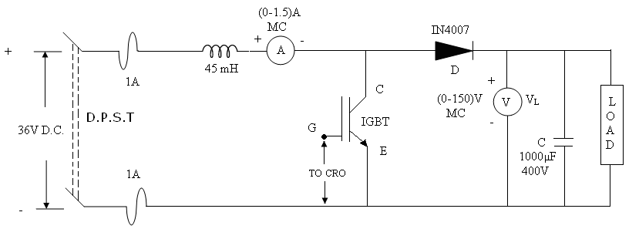

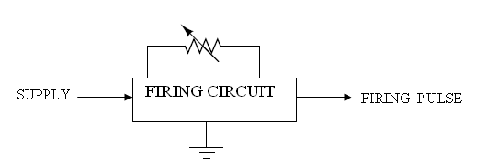

**Model Graph:**

Duty cycle

Vo/Vin

**Experiment no: 1** Date:

**BOOST CONVERTER USING IGBT**

**Aim:**

To obtain the performance characteristics of a Boost converter using IGBT.

**Components Required:**

|  |  |
| --- | --- |
| **Apparatus** | **Specifications** |
| IGBT | 600V |
| Inductor | 45mH |
| Capacitor | 1000 µF, 400 V |
| Ammeter | (0-1.5) A MC |
| Voltmeter | (0-150) V MC |
| Digital Storage Oscilloscope | -- |
| Connecting wires | -- |
| Resistive load | 750Ω/1.2A and Probe 10:1. |

**Formula used:**

The average output voltage Vo (avg)  =

Where Vo is the output voltage, Vin supply voltage in volts, δ is the duty cycle.

Where, Duty cycle, δ = $\frac{T_{oN}}{T_{on}+T_{off}}$

% Error = $\frac{V_{calc}-V_{obs}}{V_{calc}}$ x100 %

**Observation:**

Vin = ___________ V;

|  |  |  |  |  |  |  |  |  |  |
| --- | --- | --- | --- | --- | --- | --- | --- | --- | --- |
| S.No | Vo(V) | | Ton(mS) | T(mS) | δ = $\frac{Ton}{T}$ | Vo/Vin | | IL(A) | %Error |
| Measured | Cal | Measured | cal |
| 1 |  |  |  |  |  |  |  |  |  |
| 2 |  |  |  |  |  |  |  |  |  |
| 3 |  |  |  |  |  |  |  |  |  |
| 4 |  |  |  |  |  |  |  |  |  |
| 5 |  |  |  |  |  |  |  |  |  |
| 6 |  |  |  |  |  |  |  |  |  |
| 7 |  |  |  |  |  |  |  |  |  |
| 8 |  |  |  |  |  |  |  |  |  |
| 9 |  |  |  |  |  |  |  |  |  |
| 10 |  |  |  |  |  |  |  |  |  |

**Procedure:**

1. The circuit connections are to be traced as shown in the circuit diagram.
2. The DPST switch is closed and the firing circuit is connected to the gate of IGBT.
3. The firing angle and hence the turn ON time of the IGBT is varied by varying the potentiometer.
4. The corresponding values of voltages, turn ON time and the time period are noted and tabulated.
5. The characteristic curve is drawn showing the variation of duty cycle versus

Vo / Vin.

**Result:**

**Model calculation:**

**Circuit Diagram:**

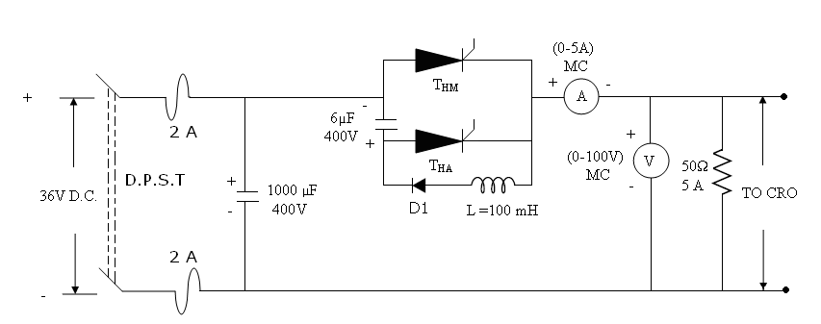

**Firing circuit:**

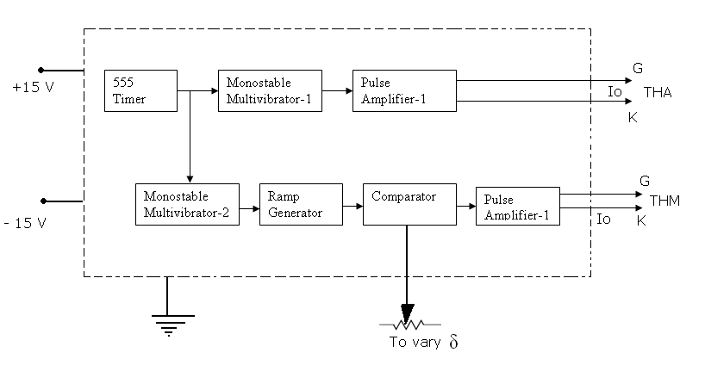

**Experiment no: 2** Date:

**VOLTAGE COMMUTATED CHOPPER**

**Aim:**

To observe and verify the performance of a voltage commutated chopper circuit.

**Components Required:**

|  |  |
| --- | --- |
| **Apparatus** | **Specifications** |
| SCR | BTW39 1200 / 30 |
| Diode | 5408 |
| Inductor | 100mH |
| Capacitors | 6µF , 400 V ; 1000µF, 400V |
| Rheostat | 50 Ω , 5A |
| Ammeter | (0-5)A MC |
| Voltmeter | (0-100) V MC |
| Cathode Ray Oscilloscope | -- |
| Connecting wires. | -- |

**Model Graph:**

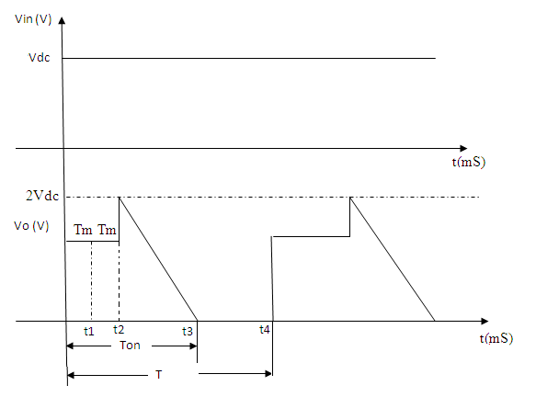

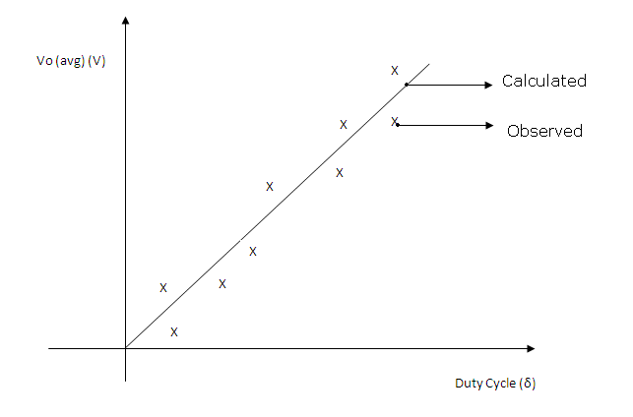

**Procedure:**

1. Trace and verify the various circuit connections in the module to be as shown in the circuit diagram.
2. Vary the duty cycle by varying position of the potentiometer knob on the front panel.
3. Connect the CRO probes to measure the output voltage.
4. Note the details of the output voltage Vo waveform, V0 (avg) from thevoltmeter reading for different values of duty cycle. Also obtain the duty cycle value from the waveform of Vo.
5. Also the theoretical output voltage Vo (avg) for various duty cycle values is calculated.
6. Tabulate the measured output voltage Vo (avg) and the predicted output voltage Vo (avg) for different values of duty cycle and compute the percentage error.
7. Plot the instantaneous output voltage waveform and the characteristic curve showing the variation of duty cycle versus Vo (avg).
8. Write your comments/observations about the method of control based on your results.
9. Simulate the circuit using SIMULINK/Power System Blockset.
10. Comment on the discrepancies between the predicted and measured results by comparison.

**Results:**

**Observation:**

Vm = _______ V ; T = __________ ;

|  |  |  |  |  |
| --- | --- | --- | --- | --- |
| S.no | Ton (mS) | Vo =Vin .δ ( V) | Vo (Avg) (V)  Measured | % Error |
| 1 |  |  |  |  |
| 2 |  |  |  |  |
| 3 |  |  |  |  |
| 4 |  |  |  |  |
| 5 |  |  |  |  |
| 6 |  |  |  |  |
| 7 |  |  |  |  |
| 8 |  |  |  |  |
| 9 |  |  |  |  |
| 10 |  |  |  |  |

**Model calculation:**

**Circuit Diagram:**

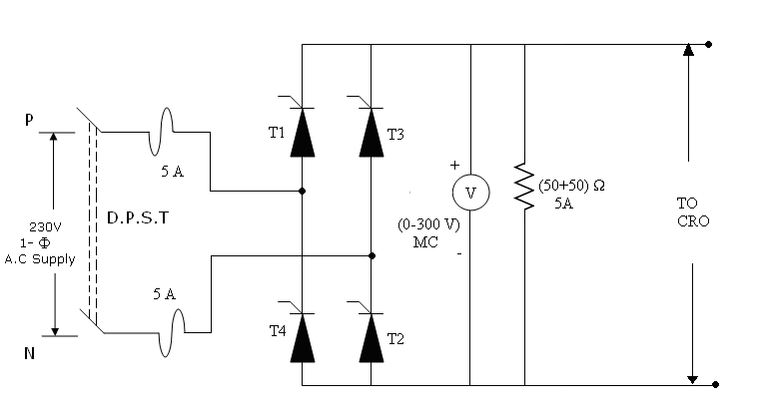

**Firing Circuit:**

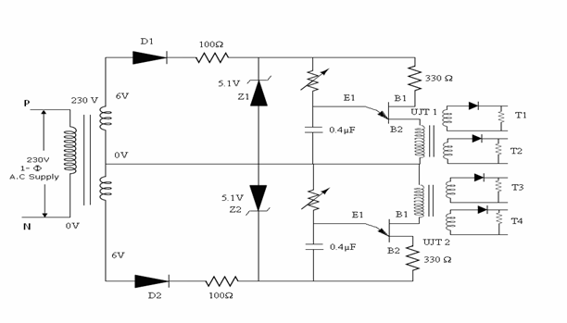

**Experiment no: 3** Date:

**SINGLE PHASE FULLY CONTROLLED SCR CONVERTER**

**Aim:**

To study the operation of a single phase fully controlledSCR converter with a resistive load.

**Components Required:**

|  |  |
| --- | --- |
| Apparatus | Specifications |
| Voltmeter | (0-300) V MC |
| Ammeter | (0- 5) A MC |
| Rheostat | (50 + 50)Ω, 5A, |
| Cathode Ray Oscilloscope | -- |
| Connecting wires | -- |

**Formulae Used:**

Vo (avg) = Vm/2 π [(2+ cos 1+ cos 2)] if 1 ≠ 2

Vo (avg) = Vm/ π [(1+ cos )] if 1 = 2

**Model Graph:**

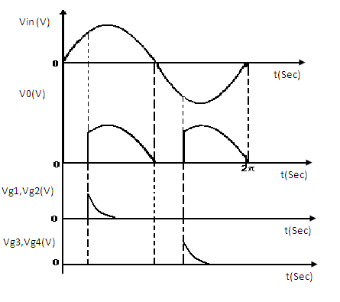

Vo(V)

Vo (Cal)

Firing angle(α)

Vo (Measured)

**`**

**Procedure:**

1. Trace and verify the various circuit connections in the converter module to be as shown in the circuit diagram.
2. Vary the rheostat setting (on the front panel) to vary the firing angle of the SCRs control the applied voltage to the load.
3. Note the readings of the supply voltage, load voltage (Vo(avg) ), and load current (Io(avg)) for various firing angles.
4. Note the instantaneous waveform of the output voltage and the firing angle for each setting of the firing angle using the CRO.
5. The average output voltage Vo(avg)  is also calculated for different firing angle values.
6. Tabulate the predicted and measured values of the (Vo(avg) ) and the percentage error.
7. Plot the instantaneous output voltage waveform and the characteristic curve showing the variation of the average output voltage versus the firing angle.
8. Write your comments/observations about the method of control based on your results.
9. Simulate the circuit using SIMULINK/Power System Blockset.
10. Comment on the discrepancies between the predicted and measured results by comparison.

**Result:**

**Observations:**

f = _________ ; T= 1/f = __________ ;

|  |  |  |  |
| --- | --- | --- | --- |
| **S.No** | **Firing Angle (α)** | **Vo (Measured) (V)** | **Vo (Cal) (V)** |
| 1 |  |  |  |
| 2 |  |  |  |
| 3 |  |  |  |
| 4 |  |  |  |
| 5 |  |  |  |
| 6 |  |  |  |
| 7 |  |  |  |
| 8 |  |  |  |
| 9 |  |  |  |
| 10 |  |  |  |

**Model calculation:**

Using Back –Back SCR’S :

**Circuit diagram:**

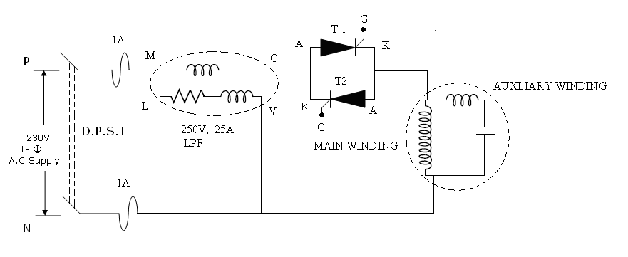

**Firing Circuit:**

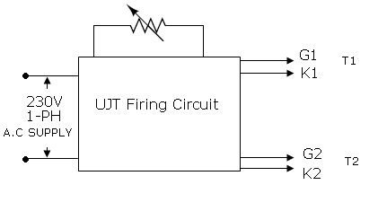

**Experiment no: 4** Date:

**SPEED CONTROL OF SINGLE PHASE CAPACITOR RUN FAN MOTOR**

**Aim:**

To study the speed control of a single- phase capacitor run fan motor using anti – parallel SCRs and to plot the performance characteristics.

**Components Required:**

|  |  |  |
| --- | --- | --- |
| Apparatus | Specifications | Quantity |
| Silicon Controlled Rectifier | -- | 2 |
| Fan motor | 60 W, 0.27A | 1 |
| Wattmeter | 250 V , 2.5 / 5A , LPF | 1 |
| Rheostat | 1060Ω , 1.7 A | 1 |

**Formula used:**

Output power = $\frac{2 π NT }{60 }$

% Efficiency = $(\frac{Output power }{Input power})$ x 100

**Model Graph:**

**Procedure:**

**Anti – parallel SCR method:**

1. Trace and verify the various circuit connections in the converter module to be as shown in the circuit diagram.
2. Vary the rheostat setting (on the front panel) to vary the firing angle of the SCRs control the applied voltage to the fan load.
3. Note the readings of the supply voltage, input power, load voltage (Vo(rms) ) and load current (Io(avg)) and the fan speed for various firing angles.
4. Tabulate the predicted and measured values of the Vo (avg) ) and the percentage error.
5. Plot the instantaneous output voltage waveform and the characteristic curve showing the variation of the average output voltage versus the firing angle.
6. Write your comments/observations about the method of control based on your results.
7. Simulate the circuit using SIMULINK/Power System Blockset.
8. Comment on the discrepancies between the predicted and measured results by comparison.
9. The circuit connections are to be traced as shown in the circuit diagram.
10. The firing angle of the anti- parallel SCRs are varied using a potentiometer and hence the speed of the fan motor.
11. The input power is measured from the wattmeter.
12. The output power is calculated using the approximation that T = kN2.
13. The characteristic curves are drawn showing the variation of fan speed versus input power, % efficiency and the torque.

**Result:**

**Tabulation:**

Anti-Parallel SCR’S:

|  |  |  |  |  |
| --- | --- | --- | --- | --- |
| S.No | Power i/p(W) | Speed(rpm) | O/P Power(W) | η (%) |
| 1 |  |  |  |  |
| 2 |  |  |  |  |
| 3 |  |  |  |  |
| 4 |  |  |  |  |
| 5 |  |  |  |  |
| 6 |  |  |  |  |
| 7 |  |  |  |  |
| 8 |  |  |  |  |

**Model calculation:**

**Circuit Diagram:**

**A.C Circuit breaker**

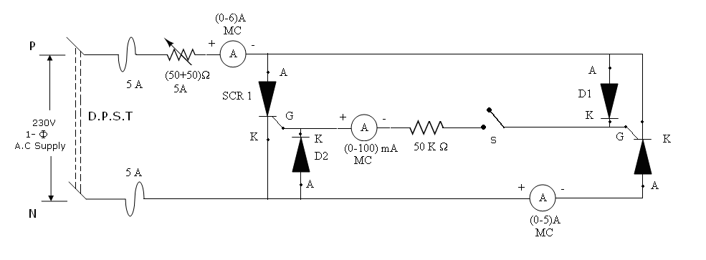

**D.C circuit breaker:**

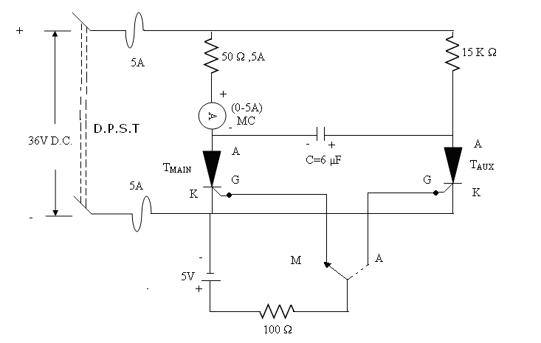

**Experiment no: 5** Date:

**AC AND DC CIRCUIT BREAKER**

**Aim:**

To test and verify the operation of ac and dc circuit breakers using thyristors.

**Components Required:**

|  |  |
| --- | --- |
| Apparatus | Specifications |
| SCR | BTW39 1200 / 30 |
| Diodes | 5408 |
| Resistor | 5 kΩ , 15 kΩ |
| Rheostat | 100 Ω, 5A ; 50 Ω , 5A |
| Ammeter | (0-6) A MI ; (0-6)A MC ; (0-100) mA MI |
| Capacitor | 6µF |
| Connecting wires | -- |

**Observations:**

A.C Circuit Breaker: ( with switch closed )

|  |  |  |  |  |
| --- | --- | --- | --- | --- |
| S.No | IL1 (A) | IL2 (A) | Ig ( A) | IL1 / IL2 |
| 1 |  |  |  |  |
| 2 |  |  |  |  |
| 3 |  |  |  |  |
| 4 |  |  |  |  |
| 5 |  |  |  |  |
| 6 |  |  |  |  |
| 7 |  |  |  |  |
| 8 |  |  |  |  |
| 9 |  |  |  |  |
| 10 |  |  |  |  |

D.C Circuit Breaker:

|  |  |  |
| --- | --- | --- |
|  | Switch at M | Switch at A |
| Load Current |  |  |

**Procedure:**

**Part-A: AC circuit breaker:**

1. Trace and verify the various circuit connections in the module to be as shown in the circuit diagram.
2. Close the DPST to connect the single – phase, 50 Hz supply.
3. Note the ammeter readings.
4. Close the switch S in the gate circuit.
5. Vary the load resistance and for each setting of the rheostat note the corresponding current levels IL1 , IL2 and the gate current Ig .
6. Open the switch S, and note the ammeter readings for IL1, IL2 and Ig.
7. Write your observations.
8. Bring the rheostat to the maximum resistance position.
9. Write your comments/observations about the method of control based on your results.
10. Simulate the circuit using SIMULINK/Power System Blockset.
11. Comment on the discrepancies between the predicted and measured results by comparison.

**Part-B: DC circuit breaker:**

**1.** Trace and verify the various circuit connections in the module to be as shown in the circuit diagram.

2. Close the DPST to connect the 36 V dc supply.

3. Note the ammeter readings for load current with the switch S in position A.

4. Now close the switch in position M. Note the current reading in the ammeter.

5. Write your comments/observations about the method of control based on your results.

6. Simulate the circuit using SIMULINK/Power System Blockset.

7 Comment on the discrepancies between the predicted and measured results by

comparison.

**Result:**

**Model calculation:**

**Circuit Diagram:**

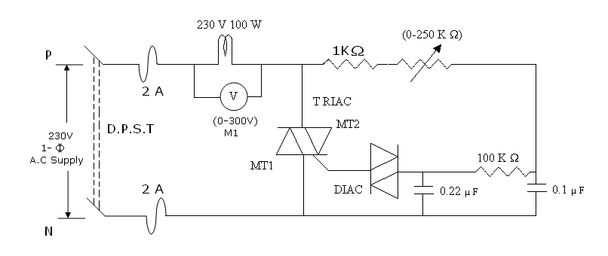

**Model Graph:**

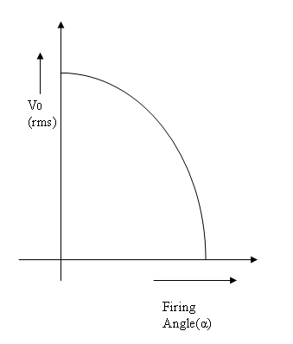

**Experiment no: 6** Date:

**ILLUMINATION CONTROL OF LAMP**

**Aim:**

To control the illumination of the lamp using (i) rheostat and (ii) triac and diac and compare the two methods.

**Components Required:**

|  |  |
| --- | --- |
| Apparatus | Specifications |
| Voltmeter | (0-300)V MI |
| Wattmeter | 250 V , 2.5 / 5A , LPF |
| Rheostat | 1060 Ω , 1.7 A |
| Resistors | 100 kΩ , 1kΩ |
| Potentiometer | (0-250) kΩ |
| Capacitor | 0.22µF ; 0.1µF |
| Triac and Diac | -- |

**Observations:**

**Vin = _______ v RL= ________ Ω**

|  |  |  |  |
| --- | --- | --- | --- |
| **S.No** | **Vo(rms) ( v)** | **Firing angle α (Degree)** | **P= Vo2/RL (Watts)** |
| 1 |  |  |  |
| 2 |  |  |  |
| 3 |  |  |  |
| 4 |  |  |  |
| 5 |  |  |  |
| 6 |  |  |  |
| 7 |  |  |  |
| 8 |  |  |  |
| 9 |  |  |  |
| 10 |  |  |  |

**Procedure:**

**Part-A Rheostatic control:**

1. Trace and verify the various circuit connections in the module to be as shown in the circuit diagram.
2. Vary the rheostat setting to vary the applied voltage and thus control the illumination of the lamp.
3. Note the readings of the supply voltage, ammeter, voltmeter connected across the lamp and the input power to the lamp for various settings of the rheostat.
4. Plot the characteristic curves showing the variation of real power, reactive power, power factor and efficiency.
5. Write your comments/observations about the method of control based on your results.
6. Simulate the circuit using SIMULINK/Power System Blockset.
7. Comment on the discrepancies between the predicted and measured results by comparison.

**Part-B Illumination control using Triac and Diac:**

1. Trace and verify the various circuit connections in the triac and diac module to be as shown in the circuit diagram.
2. Vary the rheostat setting to vary the firing angle of the triac to control the applied voltage to the lamp and thus control the illumination of the lamp.
3. Note the readings of the supply voltage, ammeter, voltmeter connected across the lamp and the input power to the lamp for various firing angles.
4. Plot the characteristic curves showing the variation of real power, reactive power, power factor and efficiency.
5. Write your comments/observations about the method of control based on your results.
6. Simulate the circuit using SIMULINK/Power System Blockset.
7. Comment on the discrepancies between the predicted and measured results by comparison.

*Compare the above two methods for illumination control and comment on their effectiveness.*

**Result:**

**Model calculation:**

**Circuit Diagram:**

**Model graph:**

**Experiment No: 7** Date:

**BUCK CONVERETER USING IGBT**

**Aim:**

To obtain performance characteristics of buck converter using IGBT.

**Components Required:**

|  |  |  |  |
| --- | --- | --- | --- |
| S.No | Apparatus | Specification | Quantity |
| 1 | IGBT | 600 V | 1 |
| 2 | Ammeter | (0-1) A, MC | 1 |
| 3 | Voltmeter | (0-60) V, MC | 1 |
| 4 | DSO | - | 1 |
| 5 | Resistive Load | 250 Ω | 1 |
| 6 | Probe | 10:1 | 1 |

**Formula used:**

1. Duty cycle, δ = $\frac{v_{0}}{v_{in}}$
2. Duty cycle, δ = $\frac{T_{oN}}{T_{on}+T_{off}}$
3. % Error = $\frac{V_{calc}-V_{obs}}{V_{calc}}$ x100 %

**Observation:**

|  |  |  |  |  |  |  |
| --- | --- | --- | --- | --- | --- | --- |
| S.No | Duty  cycle (%) | OUT PUT VOLAGE  ($v_{o}$) | OUT PUT VOLAGE  ($v_{measured}$) | % Error | $$\frac{v_{0}}{v_{in}}$$ (Calculated) | $$\frac{v_{0}}{v_{in}}$$ (Measured) |
| 1 |  |  |  |  |  |  |
| 2 |  |  |  |  |  |  |
| 3 |  |  |  |  |  |  |
| 4 |  |  |  |  |  |  |
| 5 |  |  |  |  |  |  |
| 6 |  |  |  |  |  |  |
| 7 |  |  |  |  |  |  |
| 8 |  |  |  |  |  |  |
| 9 |  |  |  |  |  |  |
| 10 |  |  |  |  |  |  |

**Procedure:**

1. The circuit connections are made as shown
2. 230 V AC supply is given to control circuit and 36 V supply is given to power circuit by closing SPST switch.
3. The DSO is connected across the gate and emitter of IGBT to tale duty cycle by Quick Measure in DSO.
4. Measure input DC voltage.
5. Vary the potentiometer in control circuit and take reading of ammeter, voltmeter and duty cycle.
6. Characteristic curve is drawn showing the duration of $\frac{v_{0}}{v_{in}}$ versus duty cycle.

**Result:**

**Model calculation:**